Guide Book for Smart Pay
- Customer login to Maersk.com Maersk Global Accounts site with Credential to access My Finance；
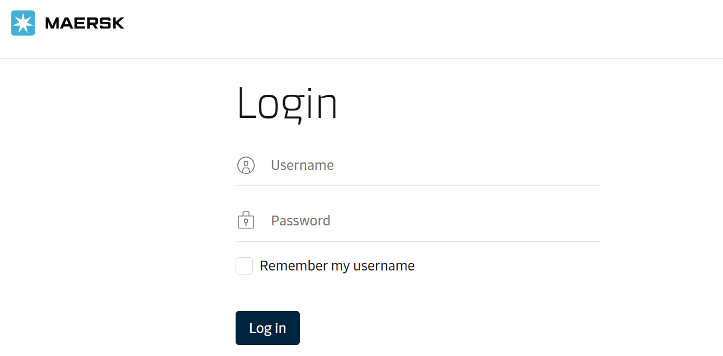
- Add new Bank Account to activate the Smart Pay Option:
- Click Account icon 
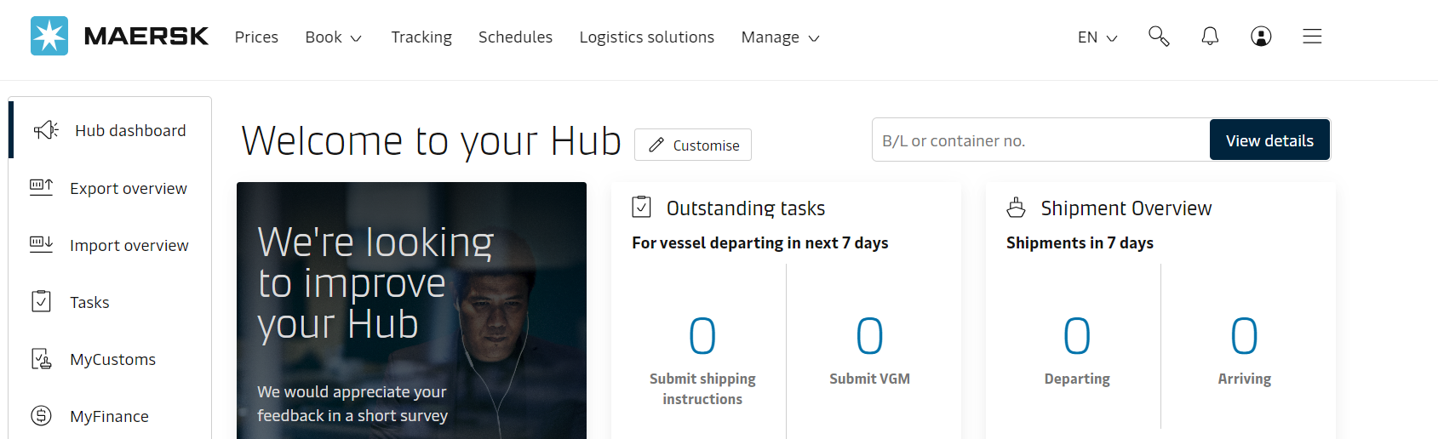
- Click Settings icon 
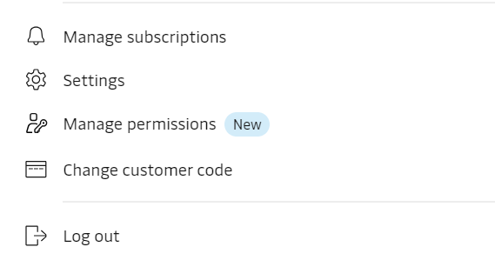
- Click on Payment Set Up Table:
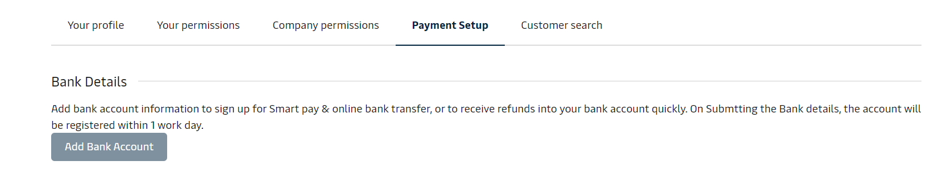
- Click on New Bank account, you will get below screen to update the Bank details & enclose required supporting document & click on Submit
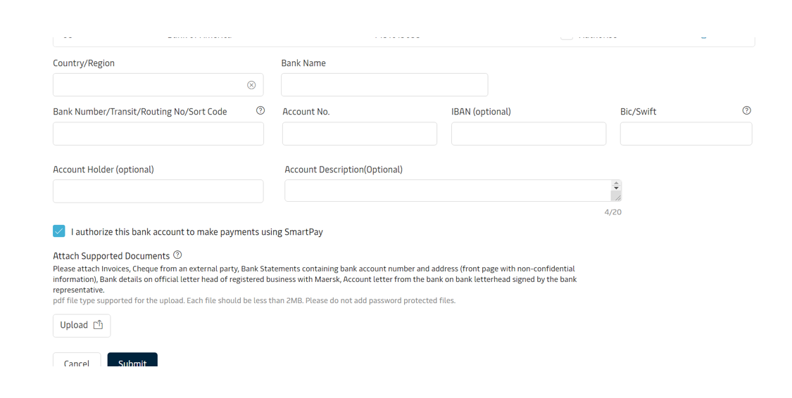
- Once the Bank request is submitted, it usually takes 1 -2 working day to be approved by Maersk Finance Team.
- Once the Bank account is approved by Maersk team it will reflect as below with
Authorise Tick. (Authorise Tick is an assurance by customer to deduct fund
from their Bank). If there is no Authorise tick, the Bank account will not be
available for payment.
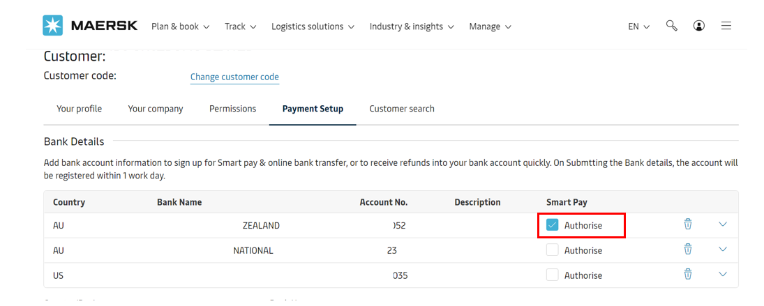
- Select Invoices in Myfinance Portal and Click Pay Button.
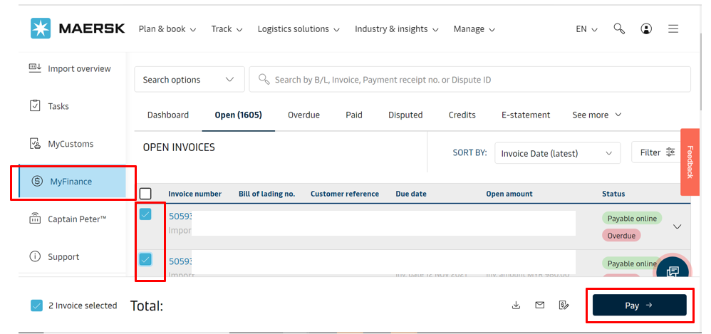
- Select Smartpay as the Payment Method.
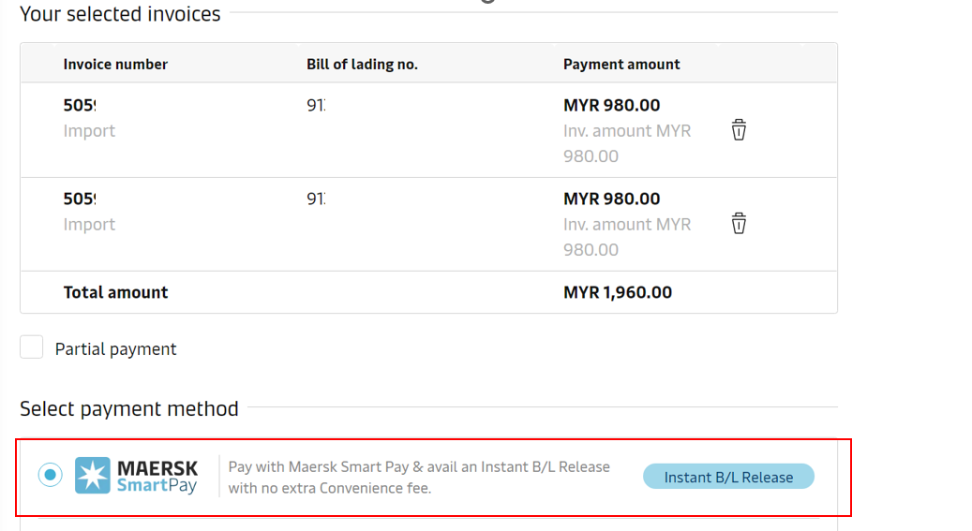
- Click accept after reviewing the terms and conditions, then click Proceed to Pay;
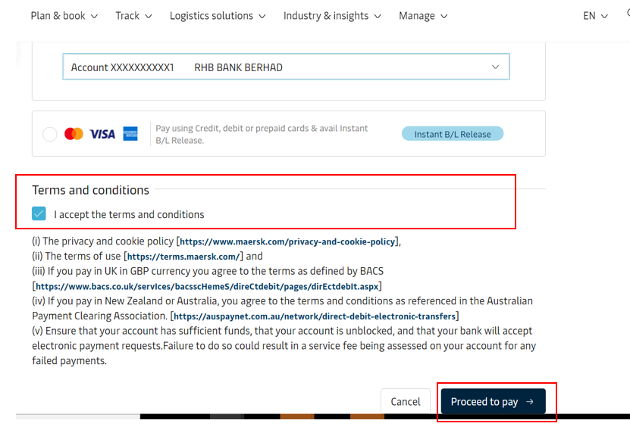
- Click “Submit Payment” if the payment information is correct.
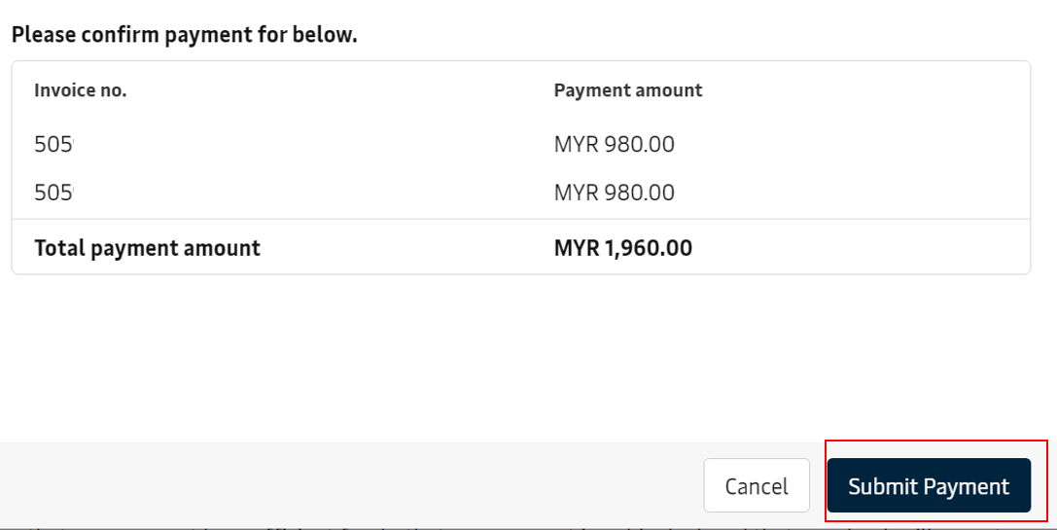
- Once payment is executed, email is triggered to customer and Invoices are moved to Paid tab.
