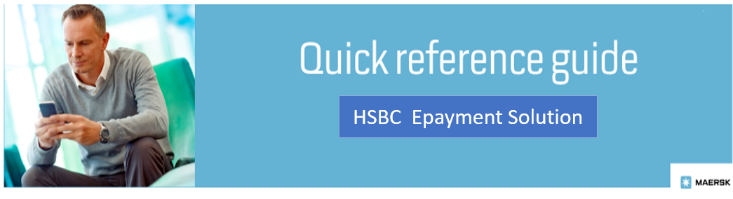

OVERVIEW:
HSBC E-Payment solution aims at allowing customers to pay Invoices online vide Internet Banking & UPI option in the MyFinance Portal on Maersk website. The intention is to enable Standard Online solution for customers to initiate payments. This solution is an easy-to-use and user-friendly solution that streamlines the payment application process.
This innovative solution will help Customers save time and effort by paying Invoice online, ensuring transparency, and facilitating faster and more secure transactions. To explore the new E-Payment solution, you should log in to the MyFinance platform. Please find below the instructions on how to login to MyFinance and navigate it. You can request access for using the solution, the functionality will start from 22nd August 2024.

CUSTOMER / AGENTS OR FREIGHT FORWARDERS ACTIONS:
- Pay invoices as per regular mode of payments – Internet Banking or UPI.
- Login to MyFinance portal:
  - Go to www.maersk.com and click on “Account”.
(First-time user? Please go to Register now to generate the ID and password).
  - Enter your credentials (username and password).
  - Click on “Manage” and Select “MyFinance”.

- Check the available options:
  - “I’m a customer” Option – Consignees will be able to pay their Invoices.
  - “I’m an agent” Option – This option enables Freight Forwarders / Agents to submit online payments on behalf of consignees.

Steps:
- Search for Invoices with BL numbers to get the list of invoices created by using the Search option on MyFinance.
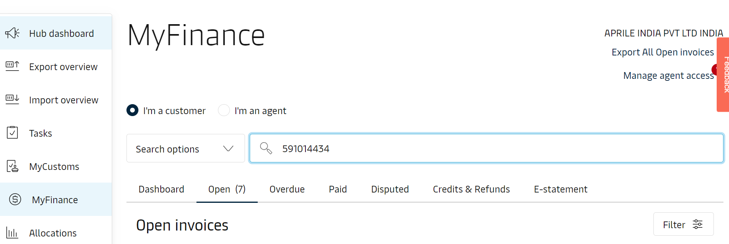
- Customers can also search specific invoices by Invoice number, or they can click on Open Invoice tab to view all the Invoices.
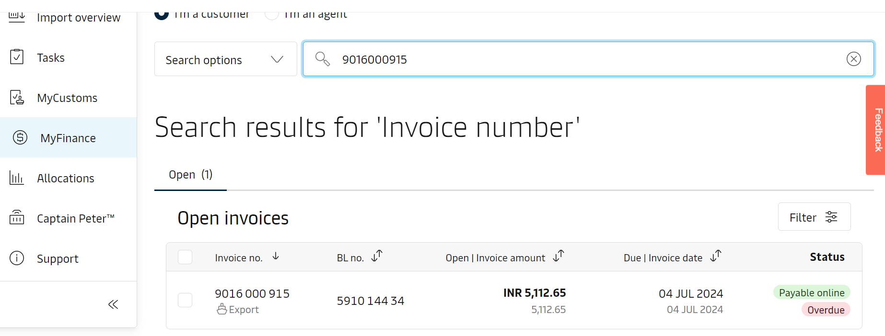
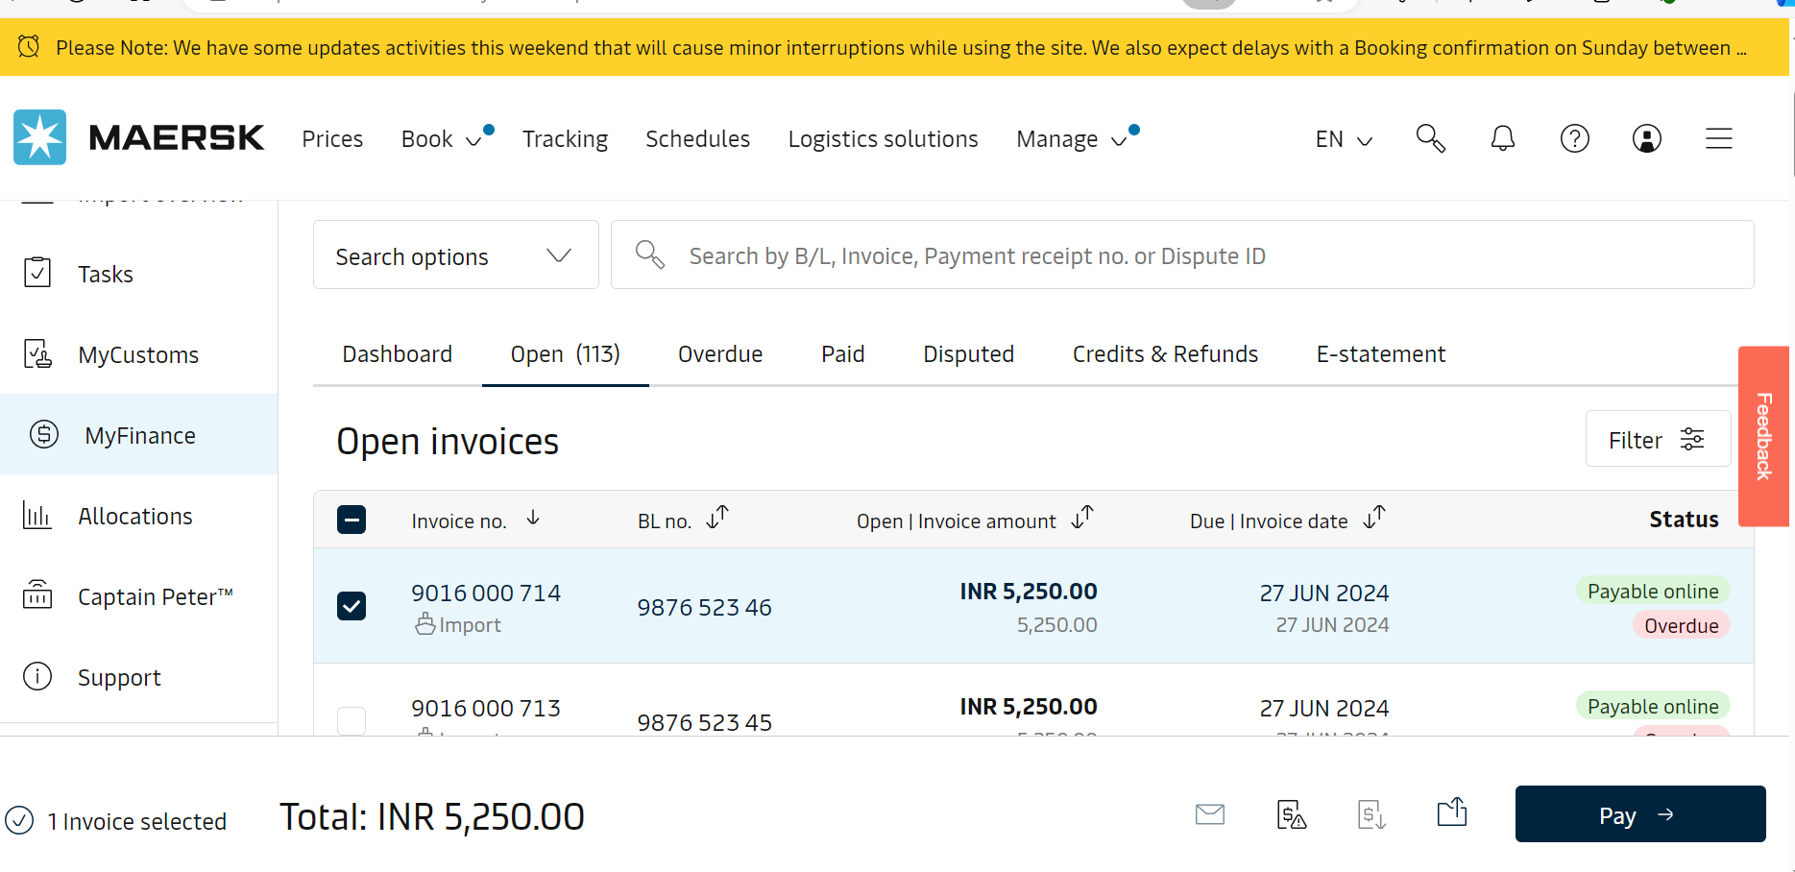

Option 1: “Search Option” on MyFinance – Consignees will be able to search Invoices via the search option or can click on Open Invoice tab to view all Invoices.

Select the invoice and click on “Pay”.

Once customers click on Pay, they are taken to the next screen to select the Epayment solution powered by Razor Pay.

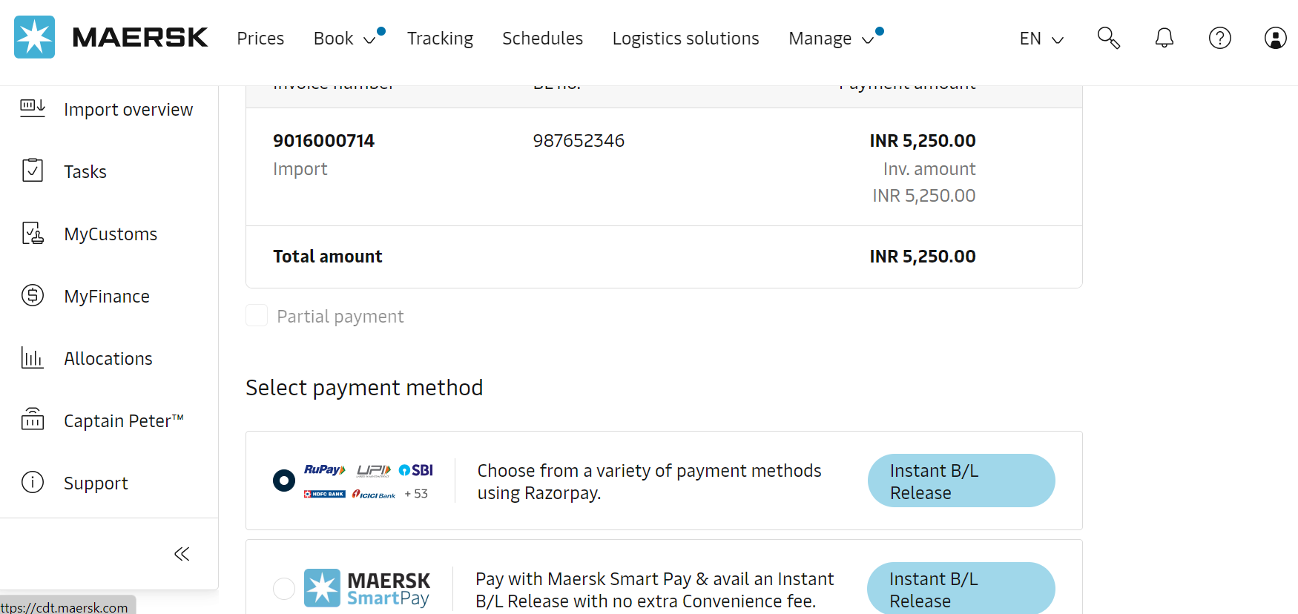
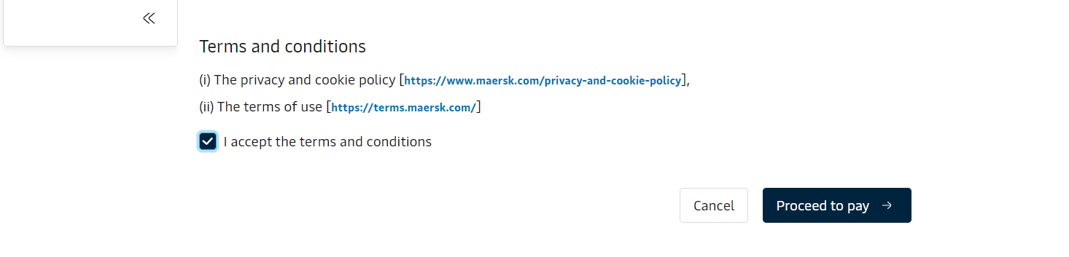

The customer must select “Razor Pay” option & click on the terms & conditions to enable “Proceed to Pay” option to proceed further with the Payment Journey.
Once they click on pay, the Razor pay widget opens giving customer 2 option to select & pay.
- Pay using “Net Banking”.
- Pay using “UPI”.

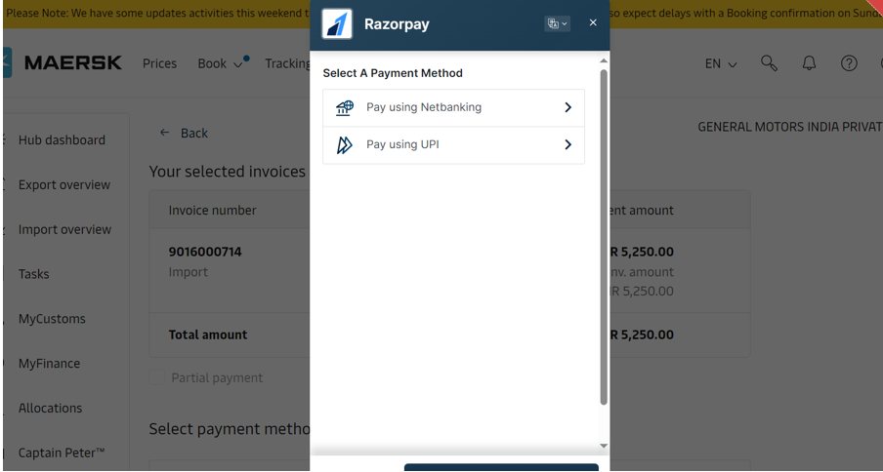

Option 1 - Net Banking:
If a customer chooses to pay using Internet Banking, the payment Gateway will provide list of Banks with whom they have a tie-up for the Payment journey. HSBC has tied-up with 40 major Banks, which will help customers select during their payment Journey.

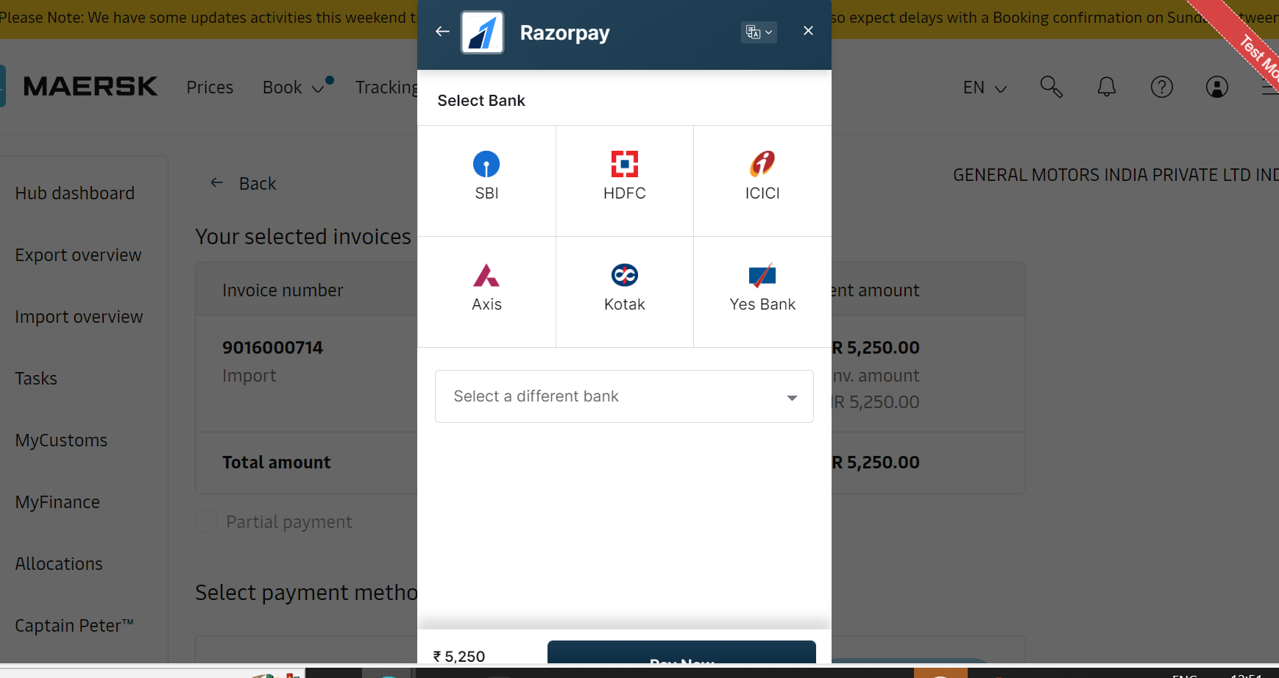

1) The customer chooses their preferred bank from the list provided by the payment gateway.
2) After selecting the bank, the payment gateway redirects the customer to the chosen bank’s website. Here, they’ll need to log in using their Net banking credentials.
3) The bank verifies the customer’s details and authorizes the transaction. If successful, the payment gateway receives confirmation and notifies Maersk to clear the Invoice in SAP.
4) When the payment process is complete, customer is redirected back to MyFinance page where they could see the Successful Payment acknowledgment.

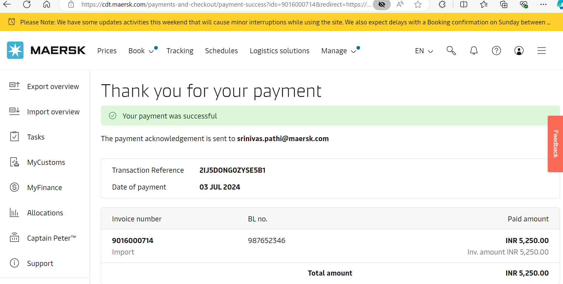
The payment acknowledgment is sent to the Customer via email and the Invoice is moved from Open to Paid
tab. You can even see the Clearing document which had knocked off the Invoice.

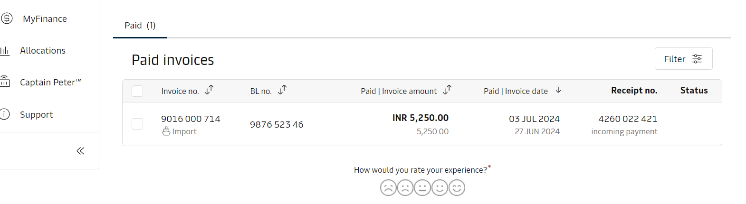

Option 2: Pay using UPI:

Customer selects the Invoice & click on “Proceed to Pay”.

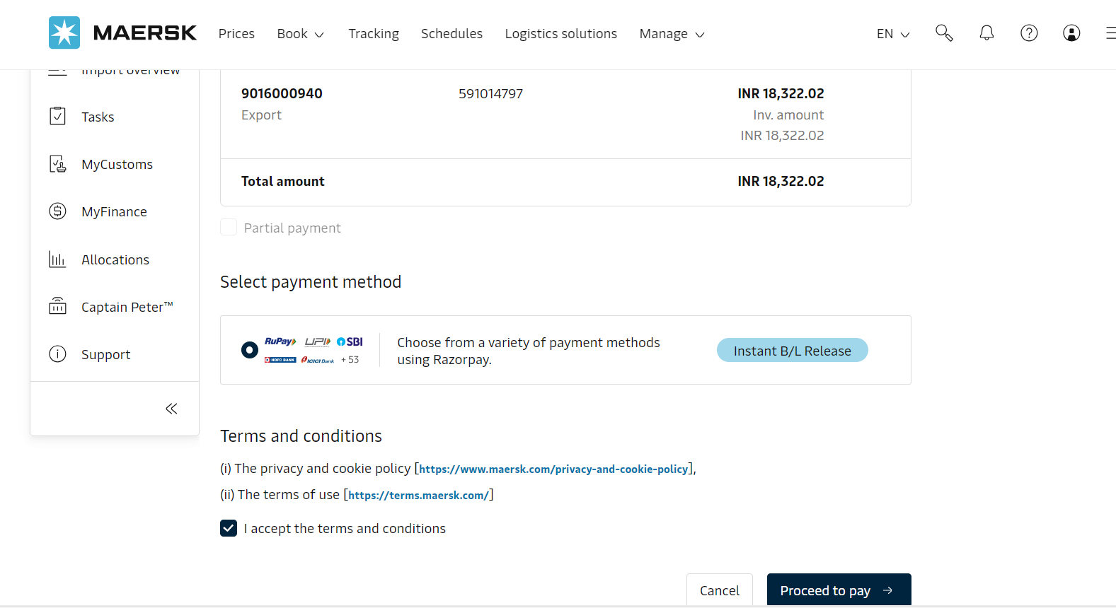

If a customer chooses to pay using UPI, they get 2 options to make the payment:
1) Scan the QR code.
2) Use UPI ID or Mobile number to which the UPI ID is linked.
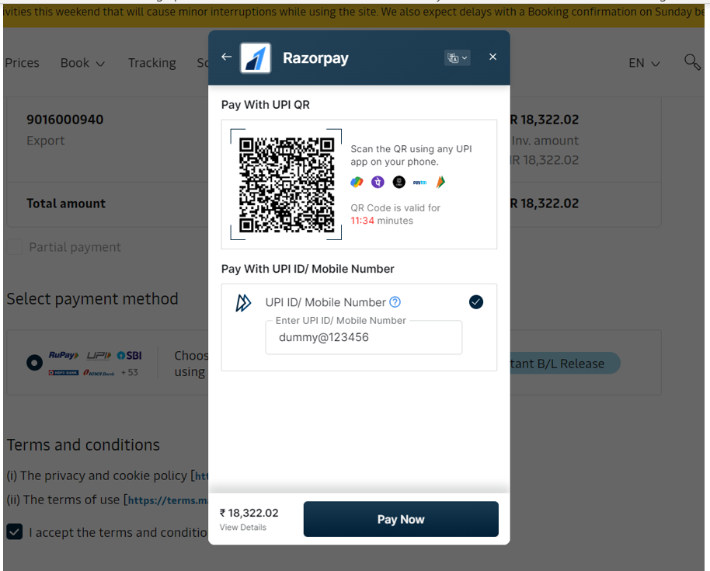
Once customer updates UPI ID or Mobile number & proceed with payment journey.
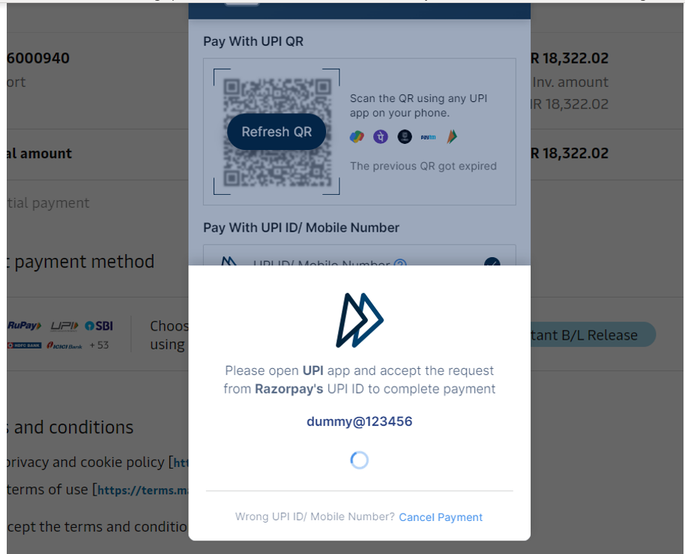

Customer gets the notification in their UPI App for payment approval. Once Customer accepts the Payment request received on UPI app, the successful payment confirmation is received with the Transaction ID and the Invoice is auto cleared.
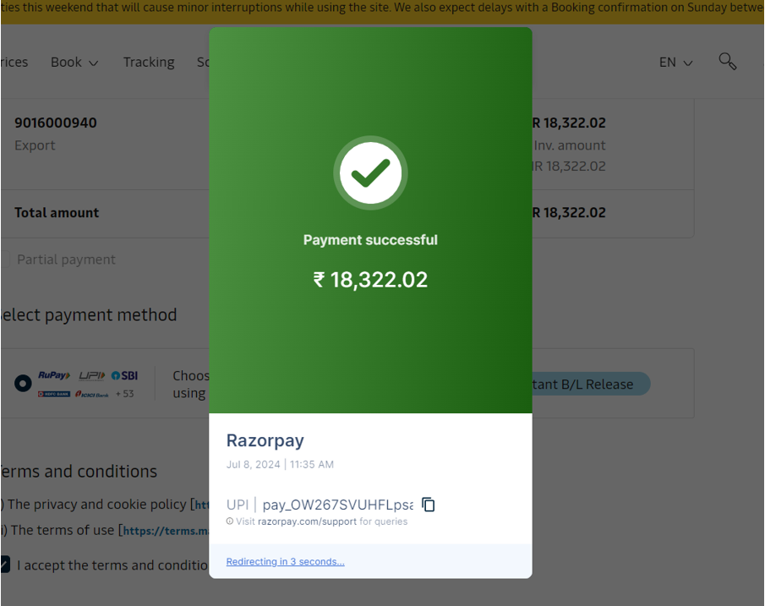

The customer also gets Payment acknowledgment from MyFinance.

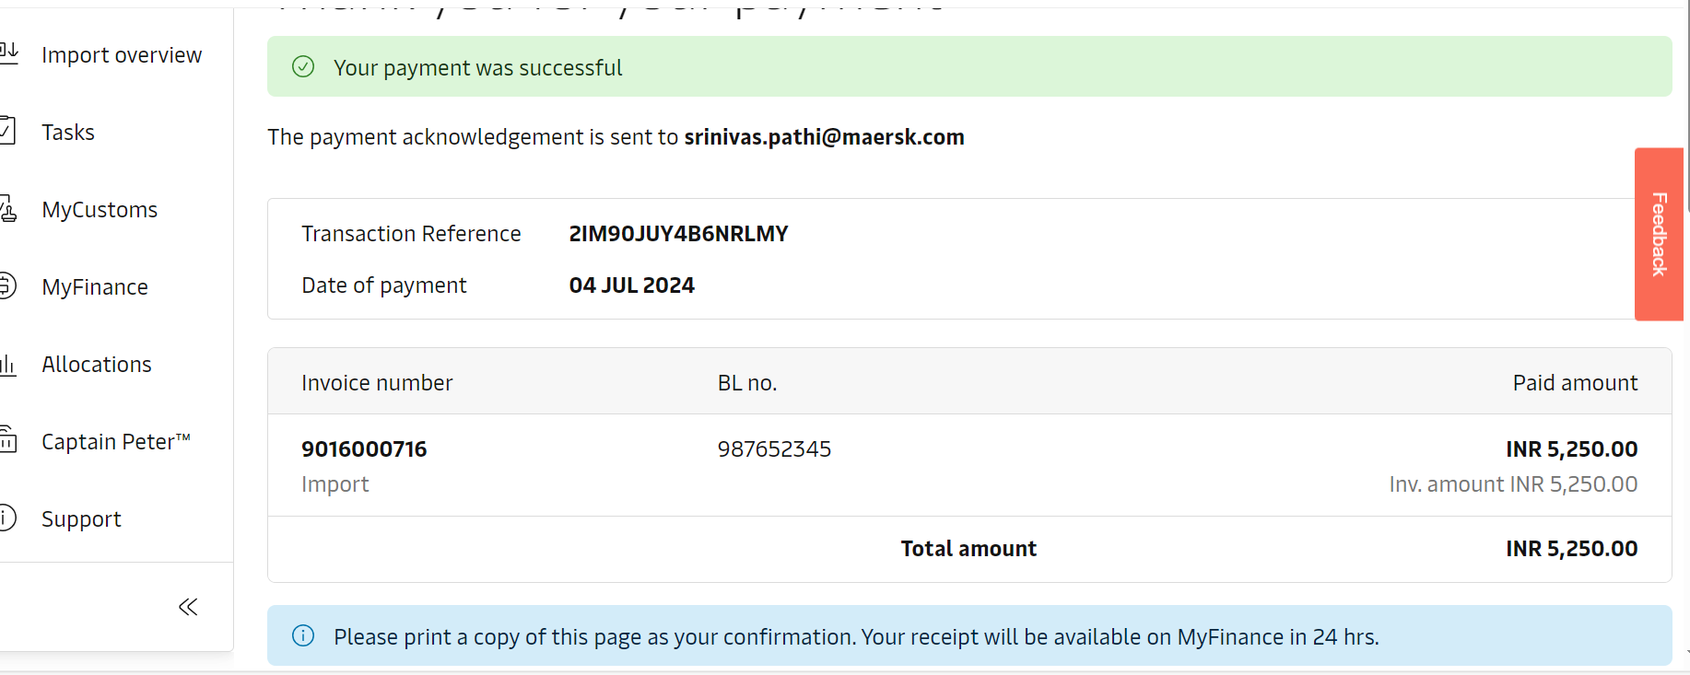
- Key Benefits to the Customers:
- It is a standard and convenient way of paying Invoices online.
- Payment application is Instant which results in faster BL or Cargo release.
- Reduced customer waiting time especially during festivals or holidays.
- There is no need to upload proof of payment.
- Payment acknowledgment once payment is successful & along with payment receipt.
- Reduction in follow-up emails from customers for getting required information for payment application.
- Live status of payment initiated.
- Who should I contact in case issue with MyFinance Access?
  - Option 1 - Please use Live Chat option on www.maersk.com
  - Option 2 - Please send an email to CENWWWSVCREG@maersk.com
- Who Should I contact in case issue with payment posting or Receipt?
  - Please reach out to your Customer Service agent with payment and invoice references.

