馬士基銷帳流程說明及注意事項
為提供更優質的服務, 我們整理以下銷帳作業的注意事項, 協助您可更順利地完成款項處理。
匯款通知郵件注意事項：
- 請於付款完成後，盡快將匯款通知發送至 CGDGSCOTCTWNCASH@maersk.com，郵件格式請參考下方的匯款通知郵件格式範本。
- 請提供付款對應的提單明細，並以可編輯格式提供。
- 若需指定統一編號，請填寫於匯款通知表格中。
- 如為進口延滯費付押款，請務必提供對應的櫃號和押至日期，以便我們快速核對。
- 收到您的匯款通知且確認款項入帳後，我們將於 4-8 個工作小時 內完成銷帳作業。您可隨時透過馬士基網站 MyFinance查詢最新狀態。
- 系統完成沖帳後，提單將自動釋放，無需等待發票或收據即可進行後續作業。
- 若貴公司已與馬士基簽訂信用帳期合約 (Credit term)，請依您的收款專員指示進行相關作業。
匯款帳號信息：
台幣帳號 | 美金帳號
受益人：台灣快桅股份有限公司  銀行名稱：花旗(台灣)商業銀行營業部  帳號：5019984038  通匯金資代碼：0210018 | 受益人：MAERSK TAIWAN LTD.  銀行名稱：Citibank Taiwan Limited  帳號：5019984208  Swift code：CITITWTX
備注：若您的業務涉及被制裁國家，如叙利亞、 古巴、 北韓、 伊朗 、克里米亞等， 請查看帳單上的收款銀行資訊，或聯繫tw.collections@maersk.com or tw.cash.collections@maersk.com
馬士基聯繫電話：
Maersk電話號碼:02-5594-0686財務轉0轉4, / 客服出口轉0 轉1/客服進口轉 0 轉 2.
匯款通知郵件格式:
- 若您的匯款不涉及進口延滯費押款，請使用這個範本。
- 反之，有付進口延滯費押款, 請選用這個，

- 填寫匯款通知郵件注意事項:
- 請將銷賬表格內容直接貼於最新一封郵件的正文，請勿放在附件或者以不可編輯的形式提供，這樣我們的自動化工具將能快速擷取關鍵資訊，提升處理效率。
- 請將整份表格複製至郵件正文中，並留意欄位位置是否正確，避免錯位導致資料判讀困難。
- 請勿在郵件正文中使用連續的「======」分隔線，此類格式可能造成系統讀取失敗，延長處理時間。
- 付款憑證仍以圖片形式附加於郵件附件中，以利我們核對。
- 表格填寫說明請參考下方圖片，以確保資訊完整且正確。

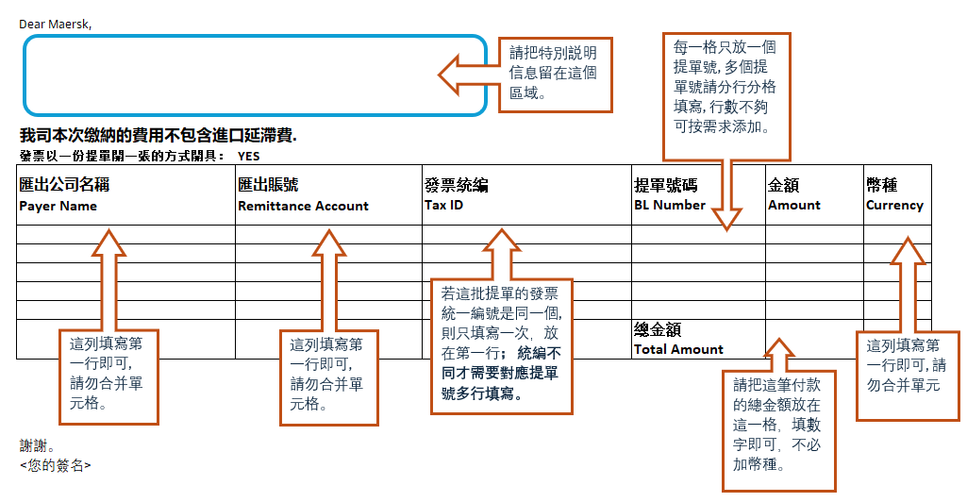

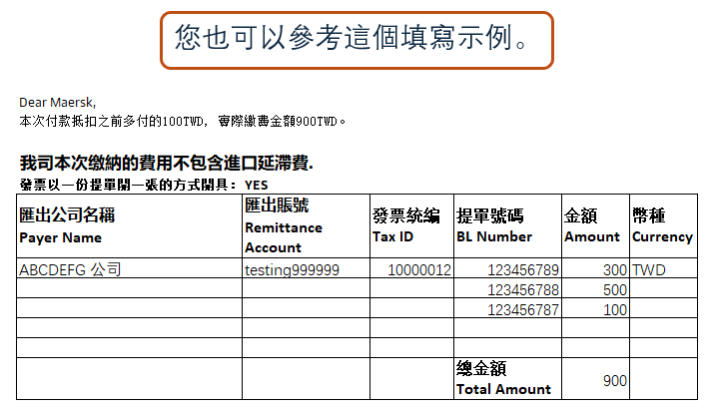

查詢與聯繫方式：
客戶查詢項目 | 對應單位聯繫郵箱
付款相關查詢/匯款通知 | CGDGSCOTCTWNCASH@maersk.com
費用爭議處理 | Disputes@maersk.com
簽有信用帳期 (Credit term) 的客戶付款問題 | tw.collections@maersk.com
立即付款客戶的應付帳款、溢付款查詢、帳單明細核對查詢 | tw.cash.collections@maersk.com
放貨事宜/海運提單/電放/領DO | 出口 | tw.export@maersk.com
放貨事宜/海運提單/電放/領DO | 進口 | tw.import@maersk.com
**您可透過 MyFinance線上平台查看/下載帳單、提出費用爭議與退款申請。

Tips for a smoother Payment application in Taiwan
To provide better service, we have compiled the following precautions for account settlement operations to assist you in completing payment processing smoothly.
- Remittance Notification Email Precautions:
- Please use the Remittance Notification email format below to input data, attach the remittance information, and send them to CGDGSCOTCTWNCASH@maersk.com.
- Provide the detailed list of Bills of lading corresponding to the payment in an editable format for your Remittance notification email.
- If you need to specify the tax number on Fapaio, please fill it in the form in the remittance notification email.
- For import detention fee deposit payments, please be sure to provide the corresponding container number and the date until which the deposit is held, so that we can verify it quickly.
- Upon receiving your remittance notification and confirming the payment received, we will complete the account settlement within 4-8 working hours. You can check the latest status anytime through the Maersk MyFinance website.
- Once the payment settlement completes in Maersk system, the bill of lading will be automatically released, and you can proceed with subsequent operations without waiting for the Fapaio or receipt.
- If your company has signed a credit term agreement with Maersk, please follow the instructions of your collection specialist for related operations.

- Maersk Remittance Account Information:
New Taiwan Dollar Account | US Dollar Account
Beneficiary: Maersk Taiwan Ltd. | Beneficiary: MAERSK TAIWAN LTD.
Bank Name: Citibank Taiwan Limited | Bank Name: Citibank Taiwan Limited
Account Number: 5019984038 | Account Number: 5019984208
Bank Code: 0210018 | Swift Code: CITITWTX

Note: If your business involves sanctioned countries (e.g., Syria, Cuba, North Korea, Iran, Crimea), please check the receiving bank information on the invoice or contact tw.collections@maersk.com or tw.cash.collections@maersk.com

- Inquiry and Contact Information:
Inquiry Items | Contact Email
Payment-related inquiries/remittance notifications | CGDGSCOTCTWNCASH@maersk.com
Dispute handling | Disputes@maersk.com
Accounts receivable inquiries (e.g., reconciliation) for credit customer payment issues | tw.collections@maersk.com
Accounts receivable inquiries (e.g., reconciliation) for cash customer payment issues | tw.cash.collections@maersk.com
Cargo release/bill of lading/telex release/DO | Export: tw.export@maersk.com  Import: tw.import@maersk.com
- You can view/download invoices, raise disputes, and request refunds through the MyFinance online platform.

- Maersk Contact Phone Numbers:
- Finance Hotline: 02-5594-0686 ext. 0, then 4
- Customer Service Export: ext. 0, then 1
- Customer Service Import: ext. 0, then 2
- Remittance Notification Email Format:
- Payment doesn’t include import detention charge, please use this email template。

- Payment includes import detention charge, please use this email template，
- Guidelines for Filling Out the Remittance Notification Email:
- Please paste the remittance excel table directly into the body of the latest email. Do not attach it as a file or provide it in a non-editable format. This allows our automation tools to quickly extract key information and improves processing efficiency.
- Please copy the entire form into the email body and ensure the column alignment is correct to avoid misinterpretation of the data.
- Do not use continuous “======” separator lines in the email body, as this format may cause system reading errors and delay processing time.
- The payment proof should still be attached as an image file in the email attachment for verification purposes.
- Please refer to the image below for instructions on how to fill out the form to ensure the information is complete and accurate

