提出フォーム

****最重要事項****
1. 日中撮影したはっきりと見える写真が必要です。
2. 以下7つのヘッダー(写真1から7まで)を消去せずサンプル写真をオリジナルの写真に差し替えてください。
3. ひとつのワードのファイルには最大8枚から9枚の写真のみお送りください。
4. お送りいただく際ワードのファイル名はコンテナ番号のみにしていただき、他の名前は付けないでください。例）BMOU2978465
5. Emailの表題: COIL/MMA approval request for Booking reference no. 912508544

Photo no.1 The pictures must be clear enough to identify if coils are not touching the floor directly
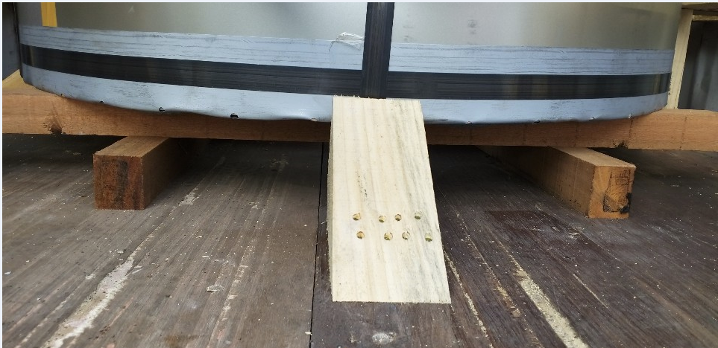

Photo no.2 Both the side secured properly with proper Blocking/bracing
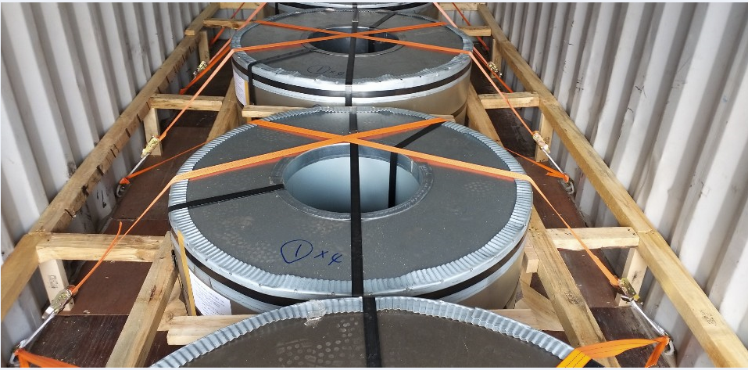

Photo no.3 Last coil in the container is not supposed to touch the container wall
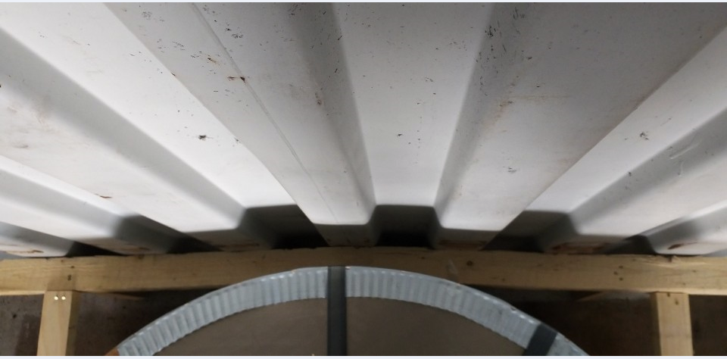

Photo no.4 Coils need to be lashed
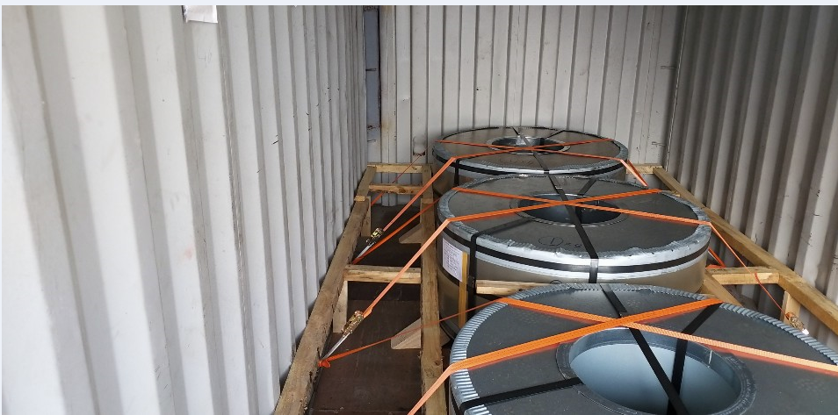

Photo no.5 Solid Bulkhead to be placed at the front rear end to arrest the motion of the commodity to door.

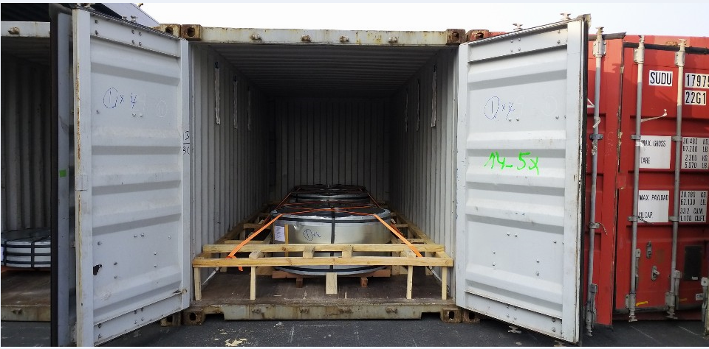

Photo no.6 Please send us clear/visible two door open photograph as we wanted to see full stuffing.

Photo no.7 We need one door shut photograph as in one picture we wanted to see the commodity stuff inside the container + container no. (In this one door shut photo complete container must be visible along with its border and edges and the commodity inside must be clearly visible. The photos must be clicked straight and not is any other angle)
