****Most Important Points****
1.WE NEED ALL THE CLEAR AND VISIBLE PHOTOS
2.Please do not remove the below mentioned 7 headings (Photo no.1 to Photo no.6) and paste the original photos instead of sample photos below all the headings
3.In one word file please send us maximum 6 to 7 photos only.
4.While sending us request please rename the word file name ONLY same as container no. and don’t give any other name. for an example file name must be “BMOU2978465”
5.Subject line of Email: Plates/MMA approval request for Booking reference no.

Container loading plans must include the following details.
The maximum payload of the container must not be exceeded.
The cargo weight must be distributed over the entire length of the container floor to prevent damage of the container floor.
If container is grounded only spreaders may be used. Use of slings or chains is NOT ACCEPTABLE

In a 20ft dry container this means that the weight must not exceed more than 4,870 kgs per meter of floor length. If it does then two wooden timbers should be laid parallel to each other lengthwise along the container floor under the plates The minimum length of the timbers to be used can be calculated by dividing the gross weight (in kilos) of the coil by 4870. If two coils are loaded side by side then the combined weight of the coils must be used in the calculation (see below)

Plates weight 10,000 kilos / 4870 = 2.05 - Timbers need to be 205 cm long

Lashing / securing
Care must be taken to ensure the plates can’t move inside the container. The plates must be lashed / secured adequately to withstand the normal forces encountered during a sea passage. The plates can be lashed using the lashing eyes located along the bottom rail of the container. Each lashing eye can take up to 2 mt. Due to the cargo weight in addition to lashing they needed to be braced using timber to prevent movement and excessive pressure against the container walls. Timber bracing used should not be against one single point of the walls but should spread the load evenly over an area of the walls. See Stuffing for further reference.

To prevent movement against the container doors a timber bulkhead should be fitted into the recess at the container doors, this slot is approximately 50 mm wide and should be used rather than the container wall corrugations to hold a bulk head. The bulkhead must not touch the container door.

B/L clause
The Merchant for liability as per Maersk Lines Terms for Carriage, in particular Chapter 11 Shipper-Packed Containers and Chapter 15 Merchant’s Responsibility. It remains the Merchant’s responsibility to ensure that the cargo is lashed and secured to ensure safe transportation under all circumstances.

http://terms.maerskline.com/carriage

Photo no.1 The pictures must be clear enough to identify if Plates are not touching the floor directly

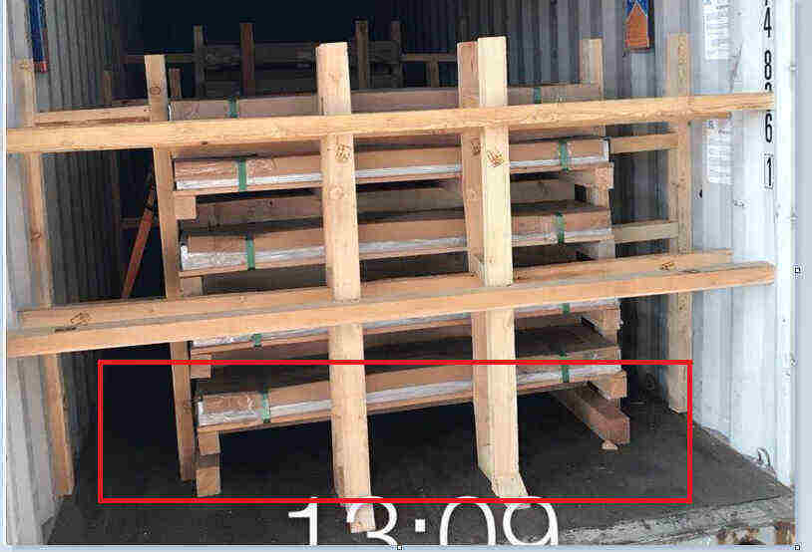

Photo no.2 Last plate in the container is not supposed to touch the container wall

The rear bulkhead with the crossbars needed as the pressure over the whole Container width must be distributed…..Use of only 2 vertical bars are not allowed

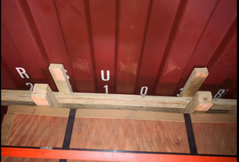

Photo no.3 Both the side secured properly with proper Blocking/bracing

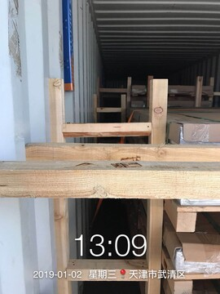
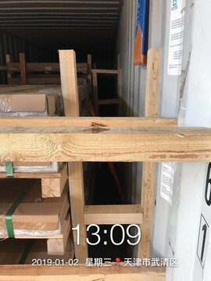
Photo no.4 Plates need to be lashed
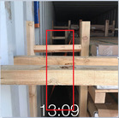

Photo no.5 Solid Bulkhead to be placed at the front rear end to arrest the motion of the commodity to door.
+
Photo no.6 Please send us clear/visible two door open photograph as we wanted to see full stuffing, (In this two-door open photo complete container must be visible along with its border and edges and the commodity inside must be clearly visible. The photos must be clicked straight and not is any other angle)
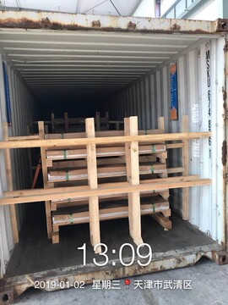
Photo no.7 We need one door shut photograph as in one picture we wanted to see the commodity stuff inside the container + container no. (In this one door shut photo complete container must be visible along with its border and edges and the commodity inside must be clearly visible. The photos must be clicked straight and not is any other angle)
