****Most Important Points****
1.WE NEED ALL THE CLEAR AND VISIBLE PHOTOS
2.Please do not remove the below mentioned 6 headings (Photo no.1 to Photo no.6) and paste the original photos instead of sample photos below all the headings
3.In one word file please send us maximum 7 to 8 photos only.
4.While sending us request please rename the word file name ONLY same as container no. and don’t give any other name. for an example file name must be “BMOU2978465”
5.Subject line of Email: MMA approval request for Booking reference no.

Photo no.1 Cargo is not supposed to touch container floor.

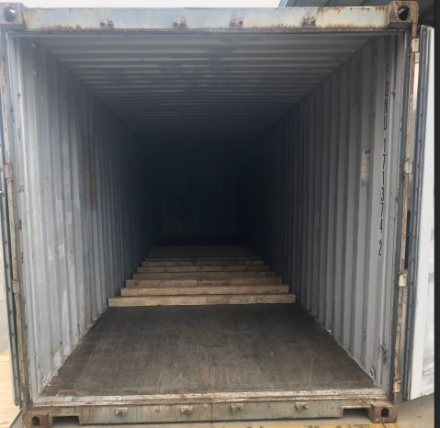

Photo no.2 Pipes need to be lashed and secured from both the sides.

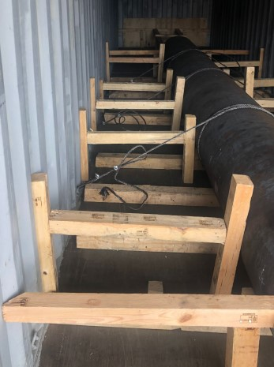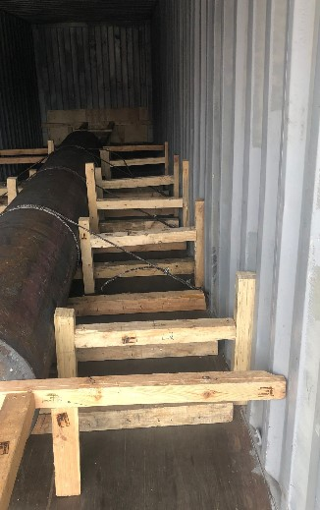

3.Back rear end need to be secured properly with strong bulkhead.

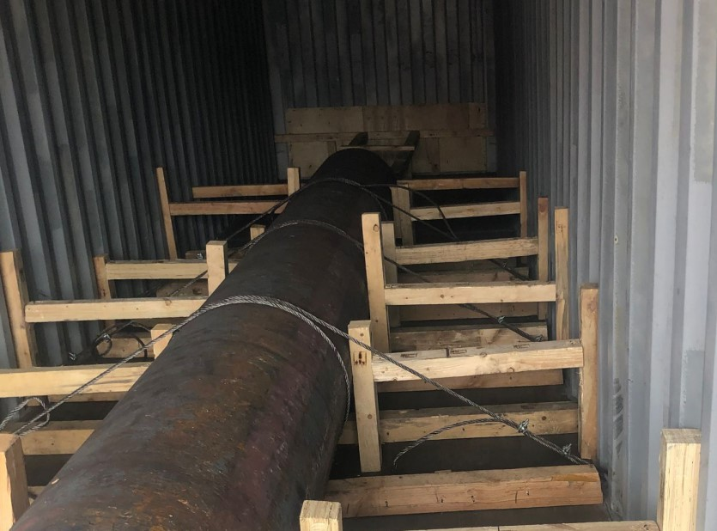

Photo no.4 Solid Bulkhead to be placed at the front rear end to arrest the motion of the commodity to door.
It is recommended that timber bulkheads are placed at both the front of the container and behind the container doors to prevent longitudinal movement and the danger of the pipes penetrating and passing through the container front wall or the doors.
The bulkhead at the door’s end must not touch the container doors.

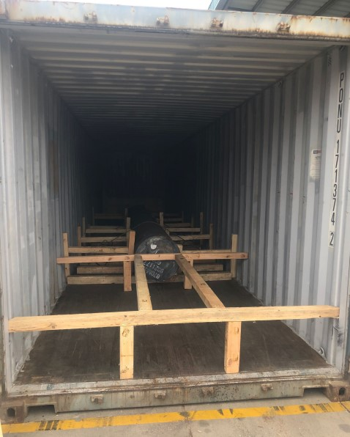

Photo no.5 Please send us clear/visible two door open photograph as we wanted to see full stuffing.
(In this two-door open photo complete container must be visible along with its border and edges and the commodity inside must be clearly visible. The photos must be clicked straight and not is any other angle)

Photo no.6 we need one door shut photograph as in one picture we wanted to see the commodity stuff inside the container + container no. (In this one door shut photo complete container must be visible along with its border and edges and the commodity inside must be clearly visible. The photos must be clicked straight and not is any other angle)

