****Most Important Points****
1.WE NEED ALL THE CLEAR AND VISIBLE PHOTOS CLICK DURING DAY TIME
2.Please do not remove the below mentioned 9 headings (Photo no.1 to Photo no.9) and paste the original photos instead of sample photos below all the headings
3.In one-word file please send us maximum 12 to 13 photos only.
4.While sending us request please rename the word file name ONLY same as container no. and don’t give any other name. for an example file name must be “BMOU2978465”
5.Subject line of Email: COIL/MMA approval request for Booking reference no.

Booking Number
Container Number
Shipper
Origin
Destination
Coil Weight
Total Weight
Coil Material

Photo no.1 The pictures must be clear enough to identify if coils are not touching the floor directly
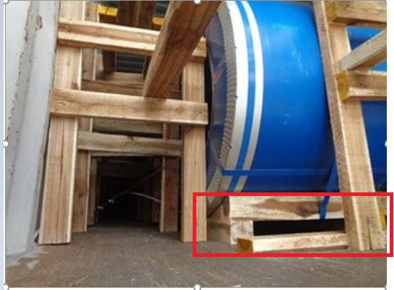

Photo no.2 Both the side secured properly with proper Blocking/bracing
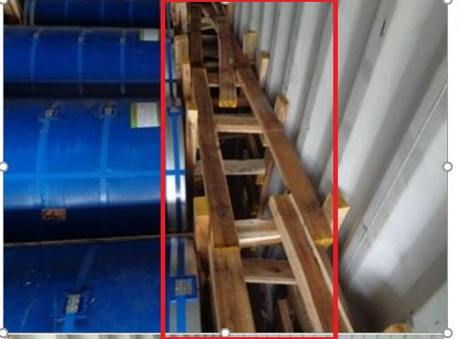

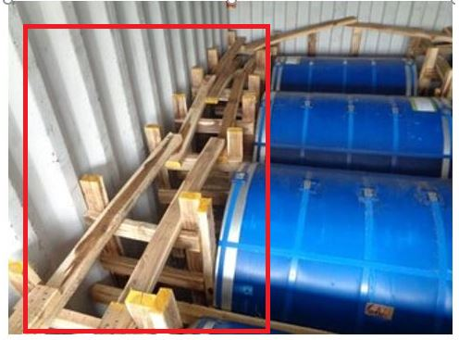

Photo no.3 Last coil in the container is not supposed to touch the container wall
The rear bulkhead with the crossbars needed as the pressure over the whole Container width must be distributed…..Use of only 2 vertical bars are not allowed
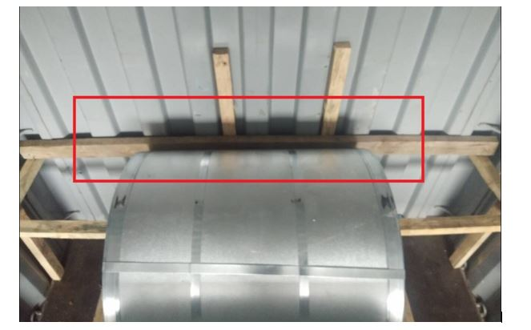
Photo no.4 Coils need to be lashed
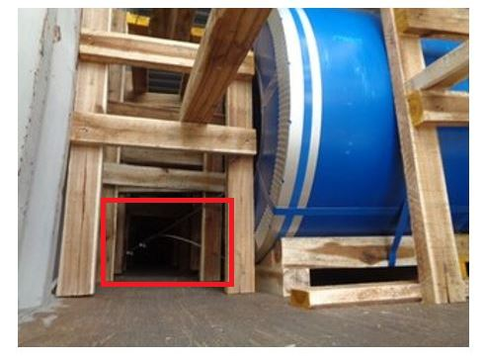
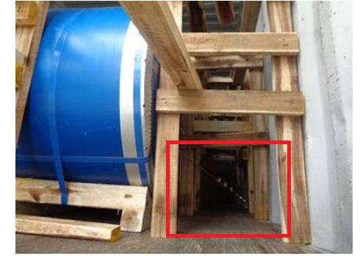

Photo no.5 A. Middle stuffing must be visible

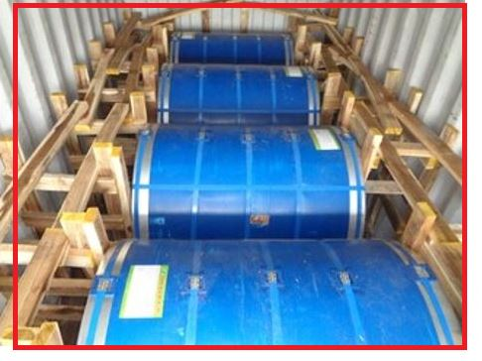

Photo no.5 B. Coil at middle of container is not place on the container floor
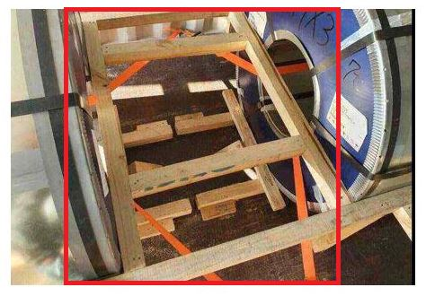

Photo no.6 Wedges need to be put below the coils to prevent it from moving
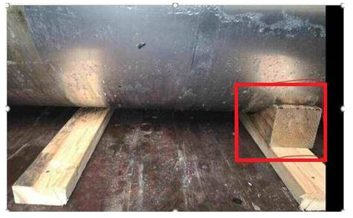
Photo no.7 Solid Bulkhead to be placed at the front rear end to arrest the motion of the commodity to door. Horizontal bars need to be fixed into corrugation of the container walls.
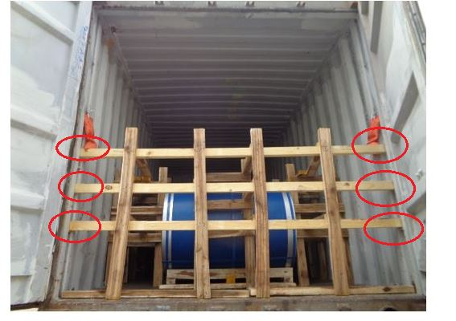

Photo no.8 Please send us clear/visible two door open photograph as we wanted to see full stuffing, (In this two-door open photo complete container must be visible along with its border and edges and the commodity inside must be clearly visible. The photos must be clicked straight and not is any other angle)

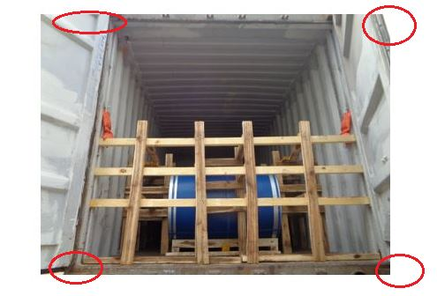

Photo no.9 We need one door shut photograph as in one picture we wanted to see the commodity stuff inside the container + container no. (In this one door shut photo complete container must be visible along with its border and edges and the commodity inside must be clearly visible. The photos must be clicked straight and not is any other angle)
