
Did you sign up with Maersk but unsure how to begin?
Here’s a ready reckoner designed to help you!

A CUSTOMER
GUIDE TO
MAERSK SERVICES
IN KENYA
Did you sign up with Maersk but unsure how to begin?
Here’s a ready reckoner designed to help you!
The first step
- Register with us
- Create a unique customer identification reference
- Log into www.mearsk.com and create your username and password
- Visit https://www.maersk.com/support/website-guide for guidance on how to proceed with this.
How do you start?
- Call us on +254 207904511 or dial 0800721125 (toll-free) and a Maersk representative will help you out.
- For any sales enquiries, you can reach us on sales.support@maersk.com
What’s next?
- You can now book your cargo with us on www.maersk.com
- Proceed to the depot to pick units
- Trucking details should be shared with the depot directly for release.

How to confirm
cargo readiness
- Engagement list
- Reefer manifest
- Late acceptance


How can Maersk.com help?
You can access a variety of services on our website. It allows you to:
- Submit Verified Gross Mass (VGM) requests
- Issue and modify shipping instructions
- Access verify copies/drafts
- Access vessel cut-off timelines/updates and online cargo readiness on https://www.maersk.com/local-information/africa/kenya/export
- To track your unit or shipment, click here
- You can also find the following services here
- C11 Amendment status• Manifest Registration Nos
- Container deposit information• Delivery order requirements
- Container re-use information• Request invoice updates
- Documents required for C11• Cut-off restrictions
- Demurrage and Detention• Documents required for Auction Cargo • Guarantee forms
We help with these service requests
Export Services |  | Import Services
- Change of Destination  - Container linking requests  - Export invoice unavailability on maersk.com  - Telex release requests  - Booking errors (please attach screenshots)  - Bill of Lading amendments (please attach screenshots)  - Split/Combine shipments after initial SI submission  - Bill of lading amendment after cargo arrives destination • Detention in transit queries  - Transit time/transport plan queries |  | - Import invoice unavailability on maersk.com after request  - Deliver Order Copy and Electric DataInterchange  - CFS Copy  - EDI cancellation  - Change of invoice party before D/O release.  - Change of Clearing Agent after D/O release.  - Validation to pick up full cargo from CFS  - C11 Amendment queries and status  - Waiver request  - Container seal discrepancy
Here’s what you should do:
- For export services as listed above, contact us via ke.export@mearsk.com
- For import services as listed in the above table, contact us via ke.import@mearsk.com
- You will receive a response in 4 working hours.
- Avail help from our online chatbot and receive instant responses.
- Call us on +254 207904511 or 080 0721125 (toll free).


Getting started with import cargo clearance
- Start by requesting an invoice update here
- Your invoice can be accessible on MyFinance portal in 2 hours. • You can start your cargo clearance 5 days from the vessel’s expected time of arrival (ETA) at Mombasa.
All help on Pre-Release
Validation (PRV)
- Note: Make a PRV request only after the local invoice has been generated
- To receive your PRV, send an email to Kenprv@maersk.com and get it processed in 2 hours
- Is your PRV being held up due to longstanding containers or outstanding invoices?
- Contact our longstanding team on kenls@maersk.com
- Contact our finance team on eaa.cash.collections@maersk.com for match-off requests and account reconciliation


What is your mode of payment?
- Bank transfers: Once you have transferred funds, share the payment advice and remittance information on eaapayapp@maersk.com for actioning.
- EURO payment: Share payment remittance and advice with Glbtpcc@maersk.com
- Mpesa: Our M-pesa paybill number is
100209 and shipment number is the same as the account number. Visit our office for a receipt.
- Cash deposit, banker’s cheque or company cheque: Visit our offices for your receipt.

Access your payment details here.
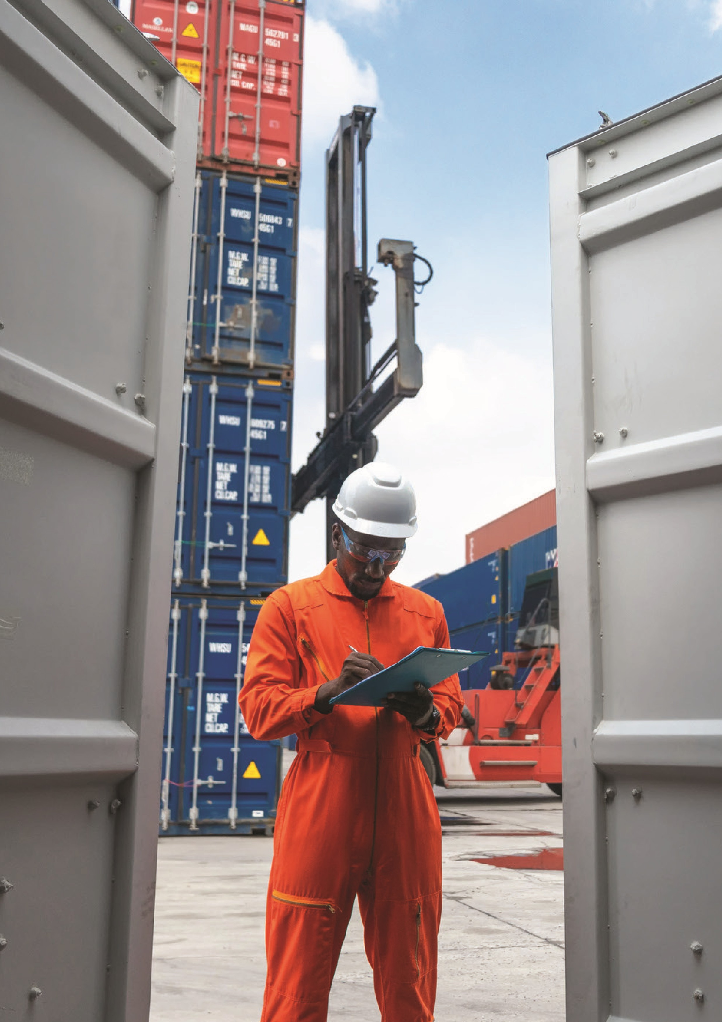
Online delivery order request
- You can place your online delivery order request on our website.
- Please refer to our delivery order requirements here • Your request will be processed within 2 hours of request.
Email contact points for miscellaneous requests
Please reach out to us for the following requests/queries by sending us an email.
- Dropping off empties – Kengscdropoff@maersk.com
- Payment receipt & remittance information - eaapayapp@maersk.com
- To receive the PRV - Kenprv@maersk.com
- Container Pre-advice and Knock-off requests – Kencntcrl@maersk.com
- Refund – Globalrefunds@maersk.com
- Dispute queries – Disputes@maersk.com
- For all longstanding queries - Kenls@mearsk.com
- Container reuse – Kencontainere-use@maersk.com
- Share engagement list/reefer manifest on target vessel through
Kenvslopsexe@maersk.com and Kencsvsl@maersk.com
- Late acceptance request - Lateacceptance@maersk.com
- Account Reconciliation and Match Off Requests - eaa.cash.collections@maersk.com
- Container Sales Customer Service: Glbconsalsd@maersk.com
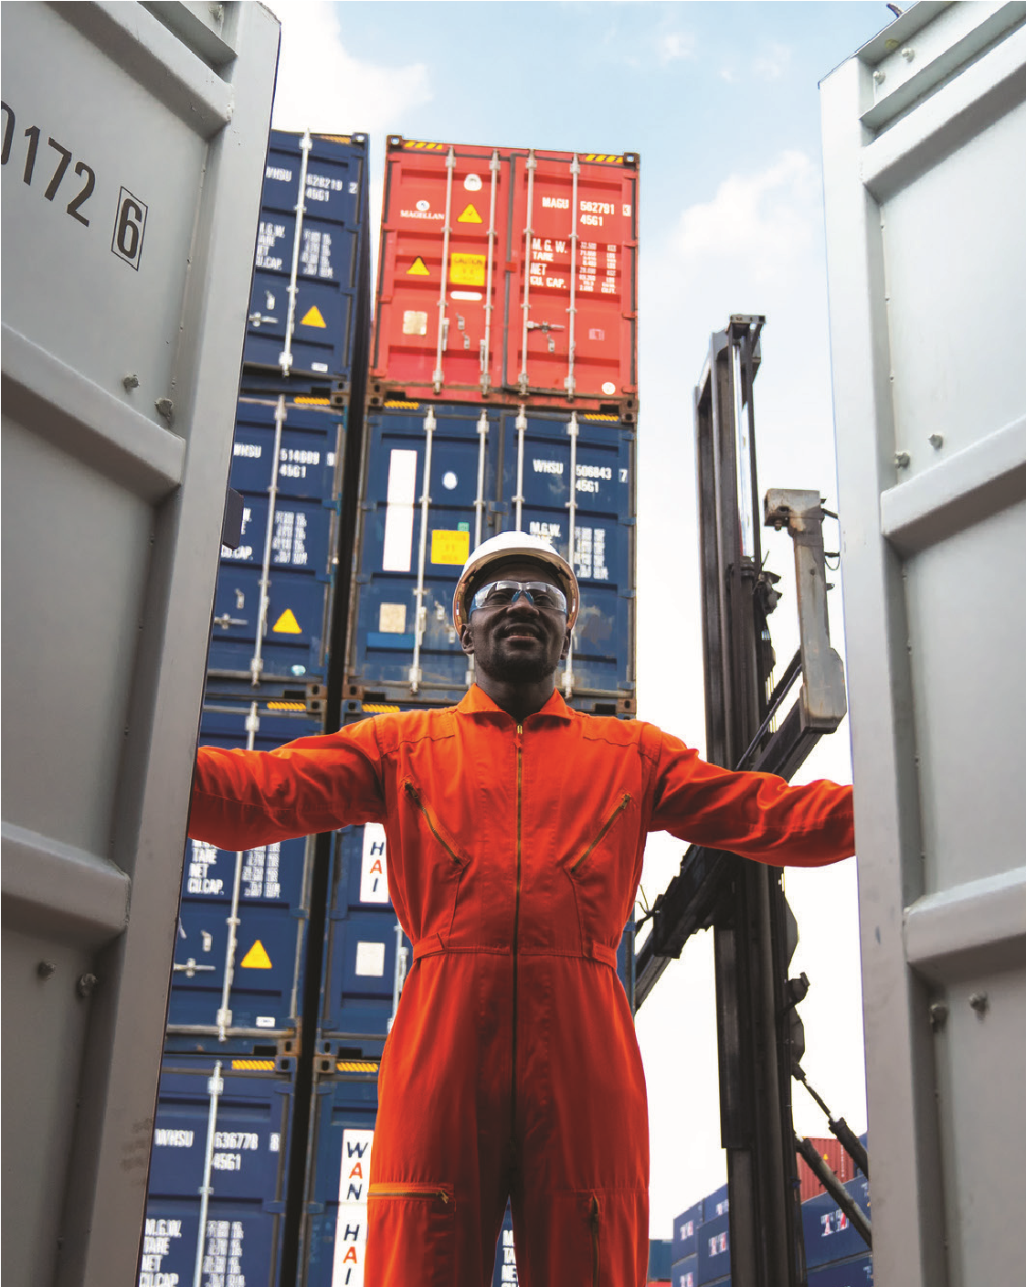
For general information and customer advisories, visit here
We are committed to attending to your service requests hassle-free and without any delays.
To facilitate this, we recommend that you address your queries, concerns and service requests only to the specific email IDs or touchpoints as outlined above.


